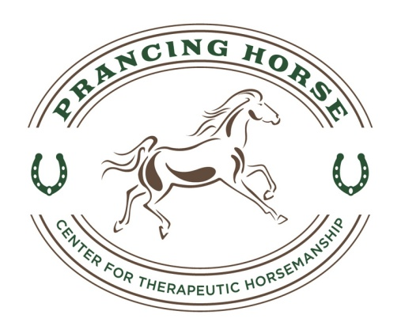
Prancing Horse, Inc
Center for Therapeutic Horsemanship

Volunteer/Staff Information Form and Health History

General Information
Name: Date:
Address:
Date of Birth: Phone: (H) (W)
Email Address:
Employer/School:
Parent/Legal Guardian/Caregiver Name/Address/Phone Number:
How did you learn about the program?
Recent medical tests: Last Tetanus Shot: Tuberculosis Test + — Date:
(Consult your physician or local health department if you are not up to date with these shots/tests)

Health History
Please describe your current health status, particularly regarding the physical/emotional demands of working in an equine-assisted program. Address fitness, cardiac, respiratory, bone or joint function, recent hospitalizations/surgeries
or lifestyle changes.

Allergies:

Medications:

Check areas in which you are interested:
Program Special Events Administration
❏Lesson Volunteer ❏ Horse Farm Tour ❏ Public Relations ❏ Photography/Video
❏ Fundraising ❏ Grant Writing ❏ Budget & Finance
A Bit Used ❏ Barn Dance ❏ Newsletter ❏ Future Planning
__Work in Tack shop ❏ Volunteer Recruitment

I understand that the information provided above is accurate to the best of my knowledge. I know of no reason why I should not participate in this center’s program.
Signature: Date:

Volunteer/Staff Information Form and Health History
Page 2

Name:
Email:
Phone: Date of Birth:

Photo Release
I ❏ DO
❏ DO NOT
consent to and authorize the use and reproduction by Prancing Horse
of any and all photographs and any other audio/visual materials taken of me for promotional material, educational activities, exhibitions or for any other use for the benefit of the program.

Signature: Date:

Background Information
Have you ever been charged with or convicted of a crime? Y N Please explain

I, (volunteer/staff), authorize Prancing Horse to receive
information from any law enforcement agency, including police departments and sheriff’s departments, of this state or any other state or federal government, to the extent permitted by state and federal law, pertaining to any convictions I may have had for violations of state or federal criminal laws, including but not limited to convictions for crimes committed upon children or animals.

I understand that such access is for the purpose of considering my application as an employee/volunteer, and I expressly DO NOT authorize the PATH Intl. Center, its directors, officers, employees or other volunteers to disseminate this information in any way to any other individual, group, agency, organization or corporation.

Signature: Date:
(volunteer/staff)

CURRENT DRIVER’S LICENSE Y N LICENSE NUMBER STATE

Confidentiality Agreement
I understand that all information (written and verbal) about participants at this PATH Intl. center is confidential and will not be shared with anyone without the expressed written consent of the participant and his/her parent/guardian in the case of a minor.

Signature: Date:
(volunteer/staff)

